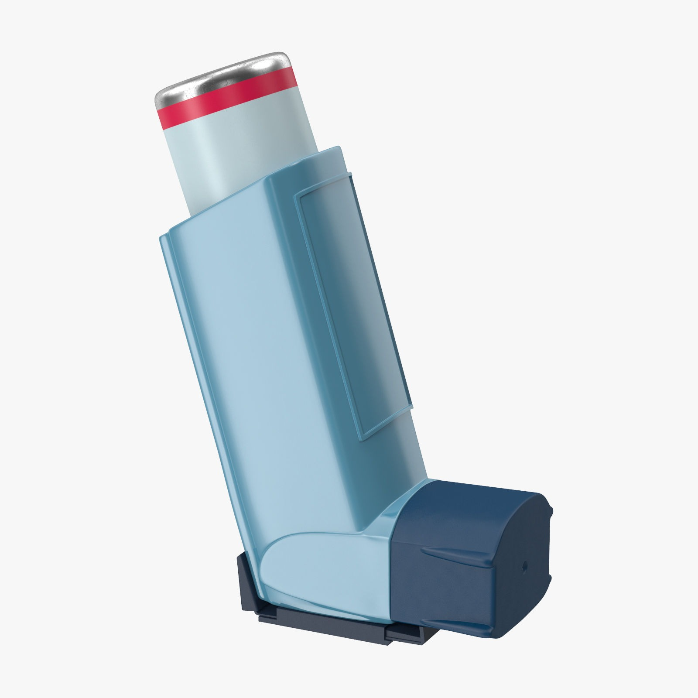

Asthma Review

|  |
| --- |
| **CONTACT DETAILS** |

Name: 

Date of Birth: 

(dd/mm/yyyy)

Mobile Phone: 

Email: 

|  |
| --- |
| **QUESTIONNAIRE** |

**1.**When was your asthma diagnosed?       

**2.**In the last month, did you have any difficulty sleeping because of your asthma symptoms (including cough)?



**3.**In the last month, did you have any asthma symptoms during the day like cough, wheeze, chest tightness or breathlessness)?



**4.**How often do you use your Asthalin/Levolin inhaler? 

**5.**In the last month has your asthma interfered with your usual activities (e.g. housework, workplace, school etc)?



Yes

**6.**Have you ever had your peak flow measured?



Yes

*If yes, do you know your best PEFR value*

 ml/min

**7.**Do you think your inhaler technique is correct?



Yes

*If not, there is an online demonstration on the* [*Asthma UK website*](https://www.google.com/search?safe=active&ei=qS0_X8O5BsKb4-EP1PyoqAs&q=the+asthma+uk+website+inhaler+technique&oq=the+asthma+uk+website&gs_lcp)

***8****.*Have you ever been demonstrated inhaler technique by your physician or nurse?

**

Yes

**9.**Have you ever smoked?



Yes

*If 'Yes', please answer the following:*

Do you smoke now?



Yes

If 'Yes' how many do you smoke each day?



There are plenty of options available to help you quit. Is this something you would like us to contact you about?



Yes

**10**.Have you ever been prescribed oral steroids due to exacerbation of Asthma?

No

Yes

**11.**Have you ever been hospitalized due to asthma?

No

Yes

If yes then how many years back? 

**12**.According to you what are the conditions or situations that exacerbate your Asthma?

[1]

**13**.Do you gurgle after taking your steroid inhaler?

No

Yes

|  |
| --- |
| **Please mail the completed Questionnaire to** [**drarghyabanerjee@gmail.com**](mailto:drarghyabanerjee@gmail.com) |

**Note:**  
By submitting this form you will be sending information about yourself across the Internet. While every effort is made to keep this information secure, guarantees of absolute privacy cannot be assured of.

Source:NHS UK,Wolds view Primary Care Centre

1.